

Integrated Resource Plan

D R A F T

December 15, 2023




Truckee Donner Public Utility District
2023 Integrated Resource Plan

Table of Contents
Executive Summary 2
Introduction and Purpose 4
Load Forecast 6
Overview 6
Methodology on Load Modifiers and Sensitivities 8
Results and IRP Inputs 12
Resources 13
Existing Resources 13
Future Resources 15
IRP Model Features and Key Assumptions 17
Load-Resource Balance Cost Primary Scenarios 21
Overview of IRP Methodology 21
Resource Portfolios 22
Sensitivity Analysis 30
Conclusion 33
Appendix A: District’s Compliance with Key State Policy Legislation and Goals 34
Appendix B: Additional IRP Model Assumptions and Findings 36
Appendix C: Additional Load Forecast Methodology 39
Appendix D: Exploratory Load Scenarios 41
Appendix E: Acronym List 42

Truckee Donner Public Utility District
2023 Integrated Resource Plan In

Executive Summary
The Truckee Donner Public Utility District (TDPUD or District) commissioned Aspen Environment Group, along with subcontractors Flynn Resource Consultants Inc. (Flynn RCI) and Better Climate (the Team), to prepare this first-ever Integrated Resource Plan (IRP) in May 2023. The team met with District Staff to clarify scope and launch the project in July. The team requested data and met with staff several times to exchange information and draft results. This report presents our analysis and findings.
The analysis consists of two key parts: the demand forecast and the resource analysis. We present three main and three alternative demand scenarios, with the alternatives designed to capture additional uncertainty. The “mid” case demand forecast reaches 247 GWh and 47.5 MW by 2040. High and low alternatives capture varying degrees of photovoltaic generation behind the customer meter, electric vehicle charging, building electrification and energy efficiency. We found the District’s load to have grown in recent years by 2.1%; the low and high demand cases modify that growth rate as well as assumptions for the various additional forecast elements. We also note that the district, in all cases, remains a winter-peaking utility. An important implication of this observation is that holding enough resources to be resource adequate in winter means the District will have excess to sell during summer, when most of the other utilities in the region reach their peak loads.
On the resource side, we analyze five different resource portfolios. For each, we compute a net present value (NPV) cost as shown in Table ES-1 below and evaluate the portfolio to ensure that it meets peak month and hourly load, meets resource adequacy requirements, has the required renewable portfolio content and meets zero-carbon, or greenhouse gas, requirements.
Table ES-1 Scope and Cost (M$) Performance of Recommended Portfolio Relative to Alternative Portfolios
Portfolio Name | Portfolio Description | NPV (M$)
Recommended | Balanced Portfolio | $201.5
No New PPA (NNP) | No new contracted resources, and rely solely on market purchases for incremental needs | $229.0
No CVP, No Stampede | No CVP, No Stampede, Add 4MW each of new utility-scale solar & 4-hour storage, 1MW of TDPUD storage and 2MW of community solar | $210.8
No Storage, High Geothermal | No battery storage (4-hr or 8-hr) and 4.5MW more geothermal resource | $192.6
High Internal Gen | Increase community solar by 10 MW, Internal 4-hour battery storage by 3MW, Utility-scale 4-hour battery storage by 2.5MW, and reduce geothermal by 3MW. | $217.6
We assess a range of sensitivities, selected to capture the impact of key uncertainties. These include natural gas costs, prices for power purchase agreements, the transmission charge to transport electricity across the NV Energy system, how the resources are counted toward resource adequacy, variability in how much hydro-electric generation occurs in a year and the pattern of change between wet and dry years. Last, the Team tests the impact of deliveries to the District from the Central Valley Project being exempt (or not) from low voltage transmission access charges. The sensitivities allow one to evaluate how different resource combinations compare in terms of not only cost, but the various key uncertainties.
In all, the Team recommends what we call the Balanced Portfolio. It is not the absolute least cost portfolio, but its composition yields the best balance of risk and cost across the various sensitivities. The Recommended portfolio is reliable in that it meets all projected demand and maintains an adequate planning reserve margin. It offers lower procurement cost than others we assembled and reduces exposure to market volatility. It complies with the State’s environmental goals and policies. It includes required resource diversity and is a good fit in terms of balancing monthly and hourly resources against loads. We have also tested that the Recommended portfolio performs well under a range of sensitivities. We recommend that the District explore the potential for increasing the proportion of geothermal or other baseload resources into the Recommended portfolio, with a corresponding decrease in reliance on solar plus storage, since this potentially could result in lower overall costs, while also increasing resource diversity.
If the District adopts the Balanced Portfolio, it must procure 38.5 MW of resources not currently in its resource mix by 2030 and an additional 7.5 MW by 2035. Importantly, we include in the portfolio a significant amount of solar plus storage. The Balanced Portfolio includes 2 MW of Community Solar and 1 MW of battery storage that could be located locally, and additional local solar and storage resources could be pursued, if feasible.
The District, in our opinion, benefits from its load profile that continues to peak in winter. This is counter to load in most of the West, excepting the Pacific Northwest. This profile puts the District in the position of being long resources when the weather makes California and the southwest resource short. Even so, the West in general is seen as either resource inadequate or close to inadequate. This, plus building and vehicle electrification, mean that the District is competing with other utilities to buy resources, and greenhouse gas goals mean those resources must be renewable. Additionally, we encourage the District to continue deployment of new energy efficiency programs, even as it electrifies. Electrification of efficient buildings assures the District is not working against itself as it procures resources.
This very first Integrated Resource Plan for TDPUD is an important step in considering resource options and compiling a broad resource portfolio that serves the District well. The consulting Team is pleased to offer our detailed analysis and findings.

Truckee Donner Public Utility District
2023 Integrated Resource Plan In

Introduction and Purpose
The Truckee Donner Public Utility District (TDPUD or District) commissioned this first-ever Integrated Resource Plan (IRP) in May 2023. An IRP explores the resources the District has and will need to assemble in order to meet the load. It considers load growth and ways to meet load, including energy efficiency, current resource contracts, and new resource opportunities. It captures statutory requirements, District goals and community desires and characteristics in crafting a guidebook the District Board and management can use to form the District’s electricity resource portfolio.
The District was established on August 9, 1927, as a Public Utility District under Division 7 of the State Public Utilities Code. At the time of its establishment, the District provided electric service only. Since 1935, the District has also provided water service within the Truckee and Donner Lake areas, with the Electric System and the District’s water system maintained and operated separately. As of December 31, 2022, the District provided electric service to 13,016 residential and 1,632 commercial, governmental, institutional and other customers. Although residential customers comprise over 88% of all customers, they consume only about 55% of total energy deliveries. The District is a winter, weekend, and holiday-peaking utility with a peak demand of around 35MW to 38MW, with a smaller but growing summer peak in July between 23MW and 25MW. The District is the sole provider of retail electric service within its service area. The District’s mission is to provide reliable, high-quality utility and customer services while managing resources in a safe, open, responsible, and environmentally sound manner at the lowest practical cost.
The District is a network transmission service customer under the currently effective joint Open Access Transmission Tariff (OATT) with Sierra Pacific Power Company (SPPC) d/b/a NV Energy (NV Energy). Its load is located entirely within NV Energy’s Balancing Authority Area (BAA) and is not directly connected to any California BAA. The District uses NV Energy’s network transmission service to import into and transport across NV Energy’s transmission grid all of the energy that is necessary to serve the District’s load. The District is a Load Serving Entity (LSE) and does not generate electricity itself. Its sources of electrical power include resources owned and/or operated by the Utah Association of Municipal Power Systems (UAMPS), Western Area Power Administration (WAPA), and Truckee-Carson Irrigation District (TCID), supplemented by market purchases. The District has entered into various agreements with these entities for electrical power which is generated from wind, solar, landfill gas, hydroelectric projects, natural gas, and other sources. UAMPS is also the Scheduling Coordinator (SC) for all energy resources received by the District.
The District is unique in that while located in California, it is electrically connected to Nevada and is virtually at the crest of the Sierra Nevada along the major Interstate and rail corridor connecting northern California with points east and to Lake Tahoe. It is host to many second homes, meaning that a portion of its population is seasonal. Snow load and tree shade prevent many homes from installing rooftop solar, and the District’s load currently peaks during winter months.
The analytical team that prepared this IRP consists of Aspen Environmental Group (Aspen), Flynn Resource Consultants Inc. (Flynn RCI), and Better Climate. The consulting team launched its work in July 2023. This report presents our results. It is organized to first review electricity demand, then resources, and the balance of those resources versus demand. It addresses several key questions, including: does the District have enough electricity under contract to meet its projected demand? How much more electricity will the District need to meet that demand over the seventeen-year forecast period? The IRP evaluates this balance for multiple resource mix scenarios or portfolios, calculating the net present value of total cost to the District to meet its load and how that present value varies as the value of key input variables vary. This allows the District to further explore resource scenarios that may have similar costs, but a wider variance around that cost. A wider variance generally means higher risk, and may indicate more uncertainty about the values of key inputs. the District must decide which resource risks it is willing to take and how to manage unavoidable risks that may be associated with different resource portfolio options. The results also calculate metrics such as whether the identified portfolio meets the District’s Greenhouse Gas emissions goals and resource adequacy requirements that may be imposed by the State of California.
IRPs require the use of analytical tools capable of evaluating and comparing the costs and benefits of a comprehensive set of alternative supply and demand resources. Supply options typically include the evaluation of new conventional generation resources, renewable energy technologies, and distributed energy resources. Demand options typically include consideration of demand response programs, energy efficiency programs, and other “behind the meter” options which may reduce the overall load that the utility must be prepared to supply. An IRP is intended to launch conversation and reflection. The conversation focuses on the magnitude and shape of the electricity load that the District must plan to meet and what resources it will use to meet those demands. Load, its shape, the type, and cost of resources to meet it, are all uncertain. A large part of the IRP process is to recognize that uncertainty and collectively evaluate those uncertainties relative to the risk preferences of the District and its customers. Overall, it is a conversation about the District’s future. Aspen, Flynn RCI and Better Climate are privileged to help lead the District’s first-ever formal conversation to plan its future in this way.

Load Forecast

Overview
Aspen developed a 17-year load forecast for the District’s 2024 Integrated Resource Plan. The approach results in annual, monthly and hourly forecasts under three main scenarios and three additional alternatives that test other potential outcomes.
Using annual load and meter count data for the last 10 years, Aspen observes the District’s annual load grew at an average of 2.1%. Generally, this is the result of new customer hook-ups, as demonstrated in the meter count data. Aspen assumed this 2.1% growth in the mid demand case. We derived the low and high demand scenarios by adding and subtracting one standard deviation from the mean growth rate. This yields 1.6% and 2.6% respectively.
Aspen modified the baseline demand for key impacts such as energy efficiency, customer-owned photovoltaic generation, electric vehicle charging and the substitution of electricity to serve uses supplied today by other fuels, such as natural gas. The demand impacts from these “modifying activities” are more uncertain than the general demand trend. Aspen aggregated these by customer class to produce the retail sales and total gross load forecast for input into the IRP.
Broadly, Aspen applied a time series approach to recorded consumption measured at customer meters to derive the monthly and hourly demand patterns. Aspen implemented its time series model using machine learning, operating on a python platform, using three years of automated meter data or advanced metering infrastructure (AMI) data for each customer class, in addition to total hourly deliveries from UAMPS to the District, back to January 2018.
Peak demand for the District historically occurs in December and varies by 2-3 MWs each year. Since 2014, peak demand has decreased; reaching 38 MWs in 2015 and only 34.5 MWs in January of 2023. By 2040, we project the peak load requirement to increase to 47.5 MWs, driven by the addition of charging load, electrification, and District population growth.
Figure 1 displays the baseline load forecast. It represents annual demand, reflecting TDPUD’s historical load, before the additional load modifiers are included.
Figure 1: Baseline Annual Load Forecast (Before Load Modifiers)
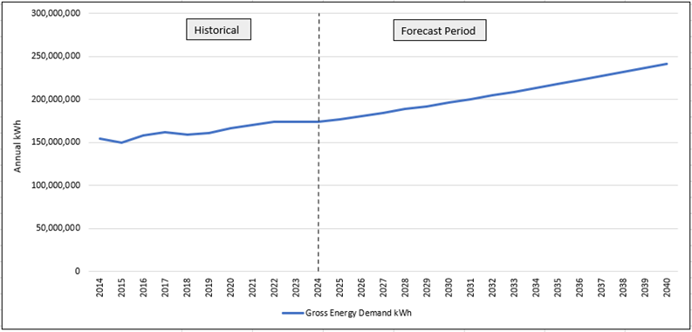
The hourly load modifiers are forecast separately and added to the baseline forecast to arrive at the annual and monthly forecast. Figure 2 provides the resulting Mid, Low and High demand cases which include the load modifiers and adjusted annual trend.
Figure 2: Annual Load Forecast Scenarios
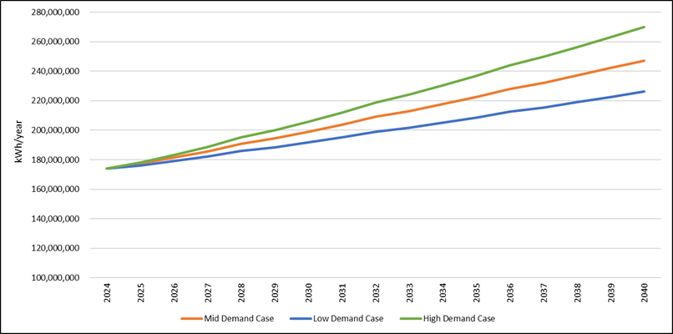
Figure 3 shows the monthly load modifier requirement (or savings) for the mid case. Electric vehicle charging and solar generation are highly dependent on the time of year due to weather, seasonal residents and tourism.
Figure 3: Monthly Load Modifier kWh requirement (or savings) for the Mid Case
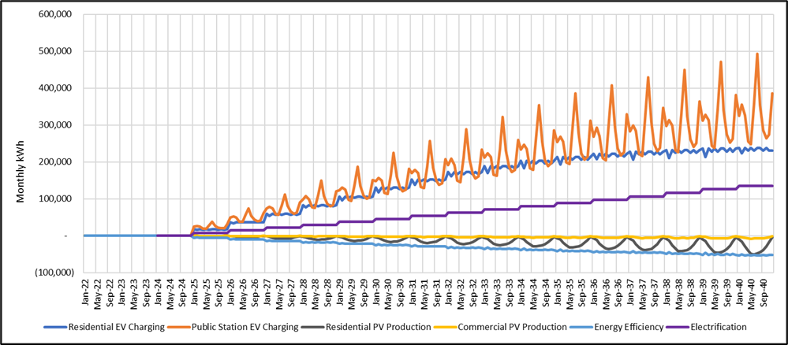
The resulting load forecast produces monthly and peak demand. Aspen also produced peak hourly profiles for August and December in 2025, 2030, 2035, and 2040. These allow the resource model to assess how various resource portfolios perform on an hourly basis as shown later in Figure 12.

Methodology on Load Modifiers and Sensitivities
Each of the load modifiers are forecast independently using TDPUD supplied data sources and publicly available data. Aspen focused on primary load concerns for the District including PV adoption, electric vehicle charging, Energy Efficiency (EE), and electrifying appliances and buildings. Where data is available, the load modifiers were forecast on an hourly basis. This results in a load profile that identifies the District’s hourly resource requirement.
Residential and commercial PV data is sourced from TDPUD’s hourly AMI data and used to develop the generation profile for solar in the Truckee area historically. This accounts for seasonality and magnitude of solar generation by hour. PV in the commercial sector is assumed to grow at half the rate of residential. In the base case, residential PV increases at 2.5% per year and commercial grows at 1.25%. The higher growth is attributed to the California required building code standards on new construction, however, growth is still considered low due to Truckee PV exemptions, which are allowed for shade cover and heavy snow load buildings. In the low load case residential and commercial PV growth rates are 5% and 2.5%.
Electric vehicle charging has a large potential for load growth for Truckee as more and more EVs are purchased coupled with the District’s higher demand from more temporary residents and visitors (leading to more vehicle trips) during tourist seasons. For residential charging, Aspen utilized DMV data and projected Plug-in Electric Vehicle (PEV) stock using a learning curve for new technologies. This was then paired with an hourly charging pattern for light duty electric vehicles from NREL to generate the load forecast. PEV market share is adjusted to fit the low and high demand sensitivity cases. Today, PEVs represent about 3% of the vehicle stock included in the DMV data for Truckee, increasing to 13% in the Mid case by the end of the forecast period. For public vehicle charging, Aspen was able to utilize TDPUD’s public charging station data in order to produce the seasonal and hourly load shape from charging. This was then coupled with the ICF Tahoe-Truckee PEV Readiness Plan trip projections to forecast charging demand. The Truckee data emphasized the impact from tourism and electric vehicle charging in the summer and more specifically in July. The current availability of 4WD EV models is limited and results in limited growth in public charging from PEV trips in the winter due to snow conditions. As more EV models reach the commercial market the EV charging load is expected to increase in the winter months as well.
In addition to the three primary load scenarios Aspen also crafted two exploratory cases for electric vehicle charging to test the bounds of potential charging requirements. The first exploratory case examined the potential for heavy duty truck charging from freight moving through the I-80 corridor and the potential for en route charging specifically in Truckee. This would require installation of ultra-fast DC MW charging capabilities and space for trucks to stop and charge along I-80. Assuming truck stop space is available, Aspen estimated an increase in the peak load requirement of 4-6 MW. This case is still speculative as these trucks are not commercially available and the charging and duty cycles have not been tested. There are also no truck stops currently located within the District where fast charging stations could be added. The second exploratory case reviewed a bookend case where all residential vehicles are electric. In this case the total load requirement increased by 26 GWh by 2040. That is about 15% of Truckee’s total demand in 2023.
Aspen crafted a case that preserves Energy Efficiency (EE), consistent with the precepts of Integrated Resource planning. This corresponds to EE having long been known as the cheapest kWh of energy. For every kWh saved, that is one less kWh to be procured. The District spent an average of $670,000 on energy efficiency programs from 2011 to 2022. Yet reported savings declined. This means that the per unit cost of the District’s EE is increasing. This is mainly attributable to the maturity of lighting replacement programs.
Figure 4: Truckee Reported Net Annual Energy Efficiency Savings
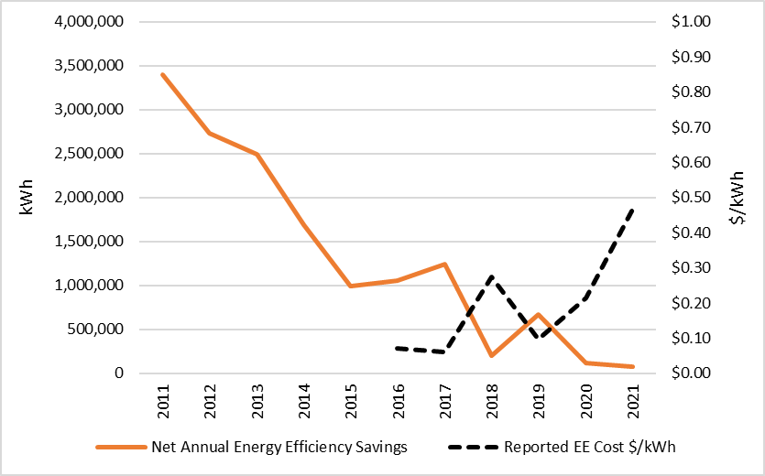
Source: CMUA SB 1037 Annual Status Reports
Figure 4 illustrates Truckee's reported net annual energy efficiency savings, sourced from CMUA SB 1037 Annual Status Reports. While traditional program spending primarily targeted EE to reduce load requirements, the same funding source is now also being allocated to electrification incentives, contributing to increased utility load and increased resource procurement to meet that load.
Whether the District cannot obtain cost-effective load savings from additional EE spending is unclear. The most recent EE potential and goals study (prepared in 2020 by GDS Associates for CMUA and submitted to the California Energy Commission) estimates the total cumulative EE potential as 2.1% of retail sales by 2040. This suggests that the TDPUD EE programs are not yet saturated and that cost-effective EE opportunities remain more available to Truckee than to other publicly-owned utilities. Whether they are or are not, the district will need to align electrification with EE, assuring Efficient Electrification. This means that the replacement of gas appliances and heat pump installations for residents should prioritize the use of the most efficient appliances and that those appliances be installed in homes with efficient building envelopes. This is essential to minimizing infrastructure upgrades and additional resource procurement costs.
The 2023 TDPUD IRP offers three load forecast scenarios. Low load represents high EE savings targets with baseline electrification, while the high load scenario prioritizes accelerated electrification with EE savings limited to its recent historical (lower) value.
Figure 5: Energy Efficiency and Electrification Scenarios
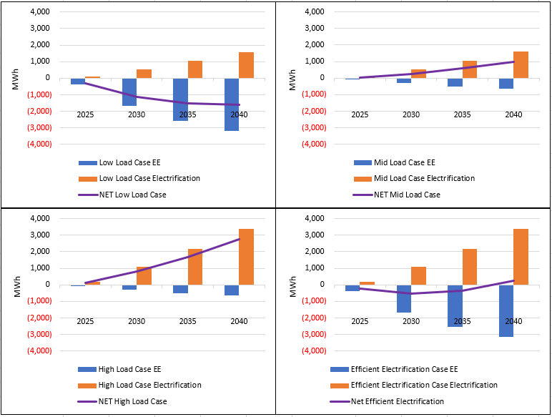
In the low load case, cumulative energy efficiency savings exceed 3 GWh by 2040, resulting from new EE programs capturing some portion of remaining potential savings for the District. Although EE cost ($/kWh) is assumed to increase over time due to diminishing returns from older EE programs, in the low load scenario the cost per kWh saved declines in 2025, 2030, 2035, and 2040 as new savings programs are initiated. Electrification load growth in the low load case is 1.5 GWh by 2040 and the resulting net load is -1.6 GWh by 2040.
The mid case assumes historical EE savings and increasing cost ($/kWh) as the programs continue to mature and the previously “low hanging” EE savings diminish. In this scenario the growth in load from electrification is not offset by the higher EE savings as seen in the previous case. Electrification load reaches ~1.5 GWh by 2040 as before, but cumulative EE savings are only ~0.6 GWh by 2040.
The high load case demonstrates accelerated electrification of up to ~3.5 GWh by 2040 and limited EE savings. This case highlights how electrification can drive load growth and peak load requirements when it is not coupled with EE. Similarly, EE costs are assumed to increase with diminishing returns without new EE programs and new efficient electric appliance programs.
An additional case the District should consider is an Efficient Electrification Scenario. It demonstrates an efficient electrification scenario modeled after the CEC’s Building Decarbonization Assessment. This case maximizes greenhouse gas (GHG) emissons reduction while mitigating load growth in place of excess procurement by pairing accelerated electrification from the high load case with the potential EE savings in the low load case. The resulting net load under this case is 227 GWh in 2040 compared to 247 GWh in the Mid load case.
Investing in traditional EE programs, such as lighting, will almost certainly yield low savings at higher costs. This does not mean that the District should abandon EE. The load forecast emphasizes the importance of planning for efficient electrification to manage load growth while aligning with California and Truckee's carbon goals. The upshot is that the District should set new EE goals for targeted EE load reduction and add separate spending to support electrification so that electrification is efficient.

Forecast Results and IRP Inputs
Figure 6 provides the resulting load forecast scenarios. Total annual load varies by 21-23 GWh between the low and high load scenarios, with a variation in the associated peak load requirement of about 4 MW. In the high load scenario, the District reaches a peak of 52 MW in December 2040. We understand that that the current transmission import capability of TDPUD is limited to 52MW. Therefore, meeting a peak load beyond 52MW could require the TDPUD could require transmission upgrades or increased reliance on local generation and/or storage as described in the Resources section.
Figure 6: Load Forecast Scenarios
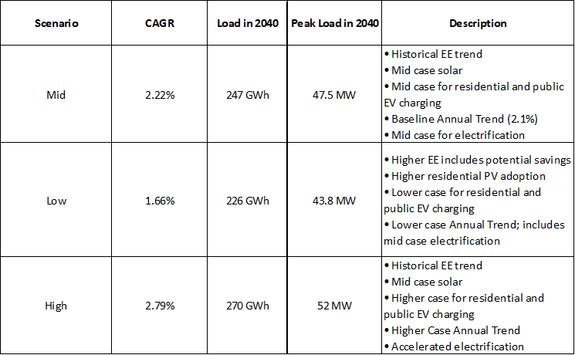
Appendix C contains additional scenarios that explore the impacts of heavy duty truck charging, 100% residential PEV charging, and the Efficient Electrification scenario. Resources

Resources

Existing Resources
Table 1 provides a summary of the District’s existing and contracted power supply resources with the District’s approximate share of each resource’s capacity in MWs. The resources highlighted in green background are Renewable Portfolio Standard (RPS)-eligible, whereas those highlighted in burgundy, such as Nebo Natural Gas, 5-Year Market purchases, and Spot Market purchases are neither RPS-eligible nor Greenhouse Gas (GHG)-free resources. The large hydro projects (>25MW in size), such as the Central Valley Project (CVP) and Veyo Waste Heat Recovery marked in blue in Table 1, are considered GHG-free but are not RPS-eligible.
Table 1: Existing Power Supply Resources
Trans-Jordan Landfill, gas, which is a base load resource that has been a key component of the TDPUD’s resource portfolio, currently serves about 16% of the District’s annual energy requirements. Its contract expires at the end of 2024, and is not expected to be renewed. Therefore, it is assumed not to be available beginning in 2025. In contrast, the 26 Foot Drop and Old Lahontan contracted resources that expire in 2023 and the Stampede resource contract that expires in 2024, are assumed to be renewed through the duration of the planning period of 2024-2040. The Central Valley Base Resource hydro project is assumed to be available beginning in 2025.

Nebo Power Station - The Utah Associated Municipal Power Systems’ (UAMPS) Nebo Power Station (Nebo), a natural gas-fired generation facility located in the central Utah city of Payson, has a maximum capacity of 146 MW. The District’s agreement with UAMPS for a 5MW share of electricity typically supplies about 10% of the District’s total annual energy needs . Nebo is taken offline twice a year in April and October for a 3 to 4-week period to perform preventive maintenance operations and minor repairs. In the IRP model, Nebo is assumed to be dispatched to meet the hourly District net loads beyond the amounts served using the existing and future potentially contracted resources.

Red Mesa Solar Project - The District has a 6 MW share of the Red Mesa Project, which equates to about 10 percent of the District's total annual energy requirements. In September 2019, the Board adopted Resolution 2019-20 authorizing the Red Mesa Tapaha Solar Project with UAMPS. The Red Mesa Project is owned and operated by the Navajo Tribal Utility Authority (NTUA). In September 2022, the Board adopted Resolution 2022-17 authorizing the amended agreement for the Red Mesa Tapaha Solar Project with UAMPS with amended pricing. The project began commercial operations on March 15, 2023.

5-Year Market Energy Purchase -The District has an existing 5-year market power purchase contract with UAMPS for 3-4 MW of power during December through March that began on April 1, 2022, and ends on March 31, 2027. The existing 5-year market power purchase represents about 20% of the District’s annual energy requirements. The market power purchase is shaped and scheduled to the District’s load profile, filling the energy ‘gaps’ in the District’s purchase power portfolio that are otherwise not supplied by other generation sources. The IRP model allows for a similar product to be available beginning April 2027.

Spot Market Purchases/Sales - The market price for energy rises or falls, primarily as the cost of natural gas changes. This is due to natural gas typically being the marginal fuel for electricity generation; therefore, natural gas power plants typically establish the market-clearing price of energy generation. As a consequence of increased natural gas prices and heavy demand for energy during the hot summer months and cold winters, market energy prices have been ranging between $100/MWh to $200/MWh for the months of July through September in Fiscal Year (FY) 2022 and $200/MWh to $250/MWh for November and December in FY 2022. The District's market energy purchases averaged $95.87 per MWh in FY 2022, compared to $64.60 per MWh in FY21, and $40.10 per MWh in FY20.

Future Resources
Table 2 provides a summary of the District’s future candidate supply resources with the approximate share of the resource’s capacity expected to be available to the District, in MWs. We have applied the same convention that we applied to Table 1 in terms of resources having RPS and GHG-free attributes. The energy associated with battery storage charging is assumed to be GHG-free, but the discharging energy is not RPS-eligible.

Table 2: Future Power Supply Candidate Resources
The Horse Butte Wind Phase II and New Lahanton hydroelectric resources are assumed to have the same characteristics and costs as the existing Horse Butte Wind and Old Lahanton hydroelectric projects. The costs for the other candidate resources were based on publicly available information about similar projects. The IRP Model described in the next section has the flexibility to add additional candidate resources. For example, we understand that there is interest in local generation beyond Community Solar, such as biomass, but the scale and scope is unknown at this time. Therefore, the biomass resources were not considered.
One important goal of resource planning is to reduce carbon emissions from generating electricity and consuming energy. Solar and wind resources meet this criterion but they operate only in hours that the sun is visible or the wind is blowing. Hence, they must be augmented by battery storage and/or resources with complementary availability. We modeled a utility-scale 4-hour battery storage resource and a separate TDPUD internal 4-hour battery storage resource. In addition, we modeled a longer-duration 8-hour battery storage resources. All battery storage resources were assumed to have 85% round-trip efficiency.
Another option considered is nuclear power resources. The nuclear option we assess is not from the old, massively large and complex 1000-MW reactors that use large quantities of water for cooling and create large amounts of spent fuel. Instead, the option here is for what are known as a “small, modular reactor” (SMR). The Nuclear Regulatory Commission has approved a 50 MW design that is being deployed now. It uses thorium as the fuel, not plutonium. The units, which are 76 feet tall by 15 feet in diameter, are each built in a factory and are identical, allowing economies of scale and scope to reduce error, schedule and cost risk. The plants are housed in a factory-looking building, with no large cooling towers, and take fractions of square miles in terms of physical footprint.
UAMPS considered participating in the Carbon Free Power Project (CFPP), which would have been located at the Idaho National Laboratory in Idaho Falls, and was envisioned to consist of six modules and generate 462 MW. In November 2023, UAMPS and NuScale agreed to terminate the CFPP. Therefore, although the TDPUD IRP model includes a provision for SMR candidate resources, such as CFPP, it is not part of any resource portfolios considered in this report.
Similar to the existing 5-year market power purchase contract that expires in March 2027, the availability of a new contract is assumed at the beginning of December 2027.

IRP Model Features and Key Assumptions
Aspen and Flynn RCI developed a customized MS Excel spreadsheet model for the District's IRP. The IRP covers the planning period of 2024-2040. It includes electric generation and load data aggregated to monthly and annual levels. However, the underlying hourly calculations are also performed to test the hourly supply-demand balance for each month. The IRP model tracks key criteria for each resource portfolio. These criteria include the ability of the District to have sufficient generation capacity to meet its peak load and planning reserve margin (PRM) to comply with California Resource Adequacy (RA) requirements. Two additional criteria are the ability of the resource portfolio to meet the State RPS and GHG-free goals, as described in detail in Appendix A.
The Power Purchase Agreement (PPA) prices for the existing resource contracts are confidential. Table 3 shows the assumed PPA prices for the generic candidate future resources in the Base scenario.

Table 3: Assumed PPA Prices (Nominal $)
Resource | PPA Price
New Solar Resource | $ 65.00/MWh*
New 4-hour Storage | $ 20.00/kW-Yr*
New 8-hour Storage | $ 23.00/kW-Yr*
New Geothermal Resource | $ 85.00/MWh**
CFPP/SMR | $ 90.00/MWh***
Community Solar | $130/MWh****
4-Hour TDPUD Storage | $24/kW-Yr****
*Source: Market intelligence applied to data from https://eta-publications.lbl.gov/sites/default/files/utility_scale_solar_2022_edition_slides.pdf
** Source: Market intelligence applied to data from https://geothermal.org/our-impact/stories/geothermal-power-purchase-agreements-rise
***Source: https://ieefa.org/resources/eye-popping-new-cost-estimates-released-nuscale-small-modular-reactor
****Assumption
The New Lahontan PPA price is assumed to be identical to the recently negotiated Old Lahontan resource. Also, we assumed a 10% premium for the Horse Butte Wind Phase II PPA price over the Horse Butte Wind Phase I price.
The market price for energy rises or falls, primarily as the cost of natural gas changes. This is due to natural gas typically being the marginal fuel for electricity generation; therefore, natural gas power plants typically establish the market-clearing price of energy generation. We used the UAMPs market price forecast for the NV Energy (NVE) area for the Base scenario and developed two additional sensitivities, a Low and a High forecast for the planning period, as shown in Figure 7 below.
Figure 7: Base, Low and High NVE Market Price Forecast ($/MWh): 2024-2040
Hydro conditions have a considerable impact on the District’s hydro generation portfolio, including Old and New Lahanton, Stampede, CVP, and 26-Foot Drop hydro units. Flynn RCI used data for Northern CA hydro generation for the last 104 years- 1920-2023 to develop distributions of dry, median, and wet hydro conditions. The probabilities of occurrence of these hydro conditions were used to randomly assign them to the planning period of 2024-2040 as shown in Table 4 below.

Table 4: Assumed Hydro Condition in Base Scenario
Year | Hydro Condition in Base Scenario
2024 | Median
2025 | Dry
2026 | Median
2027 | Wet
2028 | Wet
2029 | Median
2030 | Wet
2031 | Wet
2032 | Dry
2033 | Median
2034 | Dry
2035 | Dry
2036 | Wet
2037 | Dry
2038 | Median
2039 | Median
2040 | Wet
2041 | Median

The 2024 RA prices and Renewable Energy Credit (REC) prices are assumed to be $8/kW-Mo and $0.015/kWh, respectively, with an annual escalation rate of 2.5%. It is assumed that the District’s net short (Demand minus Supply) of RA capacity to meet the PRM and REC’s to meet the RPS goal are charged at these prices, whereas the District is paid for any surplus/net long.
The District is a network transmission service customer under the currently effective joint Open Access Transmission Tariff (OATT) of Sierra Pacific Power Company (SPPC) d/b/a NV Energy (NVE). Therefore, the District load pays the NVE transmission charge for all its deliveries from the NVE transmission system. Since the CVP resource is in the California ISO (CAISO) BAA, these import deliveries are also charged the CAISO Wheeling Access Charge (WAC). In addition to WAC charges, for deliveries that utilize transmission facilities below 200 kV, such as PG&E’s Summit Intertie Schedule Point. Low-voltage (LV) Transmission Access Charge (TAC) are applied in addition to the WAC. Flynn RCI’s proprietary TAC forecast for NVE (Base and High scenarios), CAISO WAC, and PG&E LV TAC are shown in Figure 8 below.
Figure 8: Transmission Charge Forecast ($/kWh): 2024-2040

Load-Resource Balance Cost Primary Scenarios

Overview of IRP Methodology
IRP is the process that utilities undertake to determine a long-term plan to ensure generation resources are adequate to meet projected future peak capacity and energy needs while achieving other District objectives, such as meeting Renewable Portfolio Standards and Greenhouse Gas reduction goals. Resource plans must ensure reliability is maintained at or above industry standard levels. IRPs should also forecast long-term costs with an eye towards potential rate impacts to customers to ensure that the utility can monitor and track trends with sufficient time to implement solutions to ensure reliable and affordable electric service. An effective resource plan should also provide a reasonable degree of flexibility for the utility to deal with uncertainty in technological change and future regulations.
IRPs utilize various economic analyses and methodologies to assess alternative scenarios (e.g.,
different combinations of supply and demand resources) and sensitivities to key assumptions to arrive at an economically optimal resource plan (subject to various constraints, such as regulatory mandates and local policies). We followed key steps in the resource planning process that are standard to the industry, as outlined below.

- Examine Planning Framework and Risks: Identify and assess challenges the utility faces in the current business and regulatory environment.
- Assess Needs: Develop forecasts of load changes (incorporating impacts of cost-effective demand-side resources), existing contracts, contract terms, and operational constraints to determine resource needs over the planning period.
- Consider Resource Options: Evaluate available generation resources, including centralized and distributed renewables and long-term market power purchases, to identify the role each will play in meeting customer needs and regulatory and policy goals.
- Develop Resource Portfolios: Develop resource portfolios, and evaluate them quantitatively and qualitatively to determine a preferred portfolio. Evaluation relies upon RPS and GHG-free requirements, needs assessment, and planning data specified in previous steps.
- Perform Scenario and Risk Analysis: Perform detailed evaluations of preferred resource portfolios through scenario and risk analysis to assess performance under a range of potential market and regulatory conditions.
- Identify Recommended Portfolio: Identify a “Recommended Portfolio” based on the resource portfolio expected to reliably serve demand at a reasonable long-term cost, while achieving regulatory compliance, accounting for inherent risks, and allowing for flexibility to respond to future policy changes.

Resource Portfolios
The District’s near-term (2025) electric supply portfolio comprises the following major types of resources:
- Energy efficiency (EE);
- Federal hydro (Stampede and CVP);
- Other hydro (Old and New Lahanton, and 26 Foot Drop hydro);
- Long-term RPS-eligible PPAs, which include solar, wind, and waste heat resources;
- Natural gas-fired (Nebo);
- Contracted and spot market power purchases for monthly/hourly portfolio balancing.
For calendar year 2025, the projected contribution of the supply resources to the District’s overall electric supply portfolio is represented in Figure 9 below.
Figure 9: Projected District Electric Supply Mix in CY 2025 by Resource Type
* Estimated Average Annual Unit Cost of 9.9 ¢/kWh *
By applying the six (6) steps described under the IRP Methodology, we determined the recommended resource portfolio that selects the resources as shown in Table 5 below.

Table 5: Recommended Resource Portfolio Selection*
Resources | Start Year | End Year | Capacity
Horse Butte Wind Phase I | 2024 | N/A | 15.00
Pleasant Valley Wind | 2024 | N/A | 0.25
Trans-Jordan Landfill Gas | 2024 | 2024 | 3.20
Nebo Natural Gas | 2024 | N/A | 5.14
Veyo Waste Heat Recovery | 2024 | N/A | 1.70
Red Mesa Solar | 2024 | N/A | 6.00
Stampede Powerplant WAPA 4.0 | 2024 | N/A | 4.00
26 Foot Drop Hydro | 2024 | N/A | 1.00
Central Valley Project WAPA 2.0 2025 | 2024 | N/A | 2.00
Old Lahontan Hydroelectric | 2024 | N/A | 2.70
5-Year Market Purchase | 2024 | 2027 | 4.00
Horse Butte Wind Phase II | 2026 | N/A | 11.05
Geothermal Resource | 2027 | N/A | 2.45
4-Hour Solar Plus Storage Resource - Solar | 2027 | N/A | 6.00
4-Hour Solar Plus Storage Resource - Storage | 2027 | N/A | 3.00
8-Hour Solar Plus Storage Resource - Solar | 2027 | N/A | 6.00
8-Hour Solar Plus Storage Resource - Storage | 2027 | N/A | 3.00
Carbon Free Power Project | 2099 | N/A | 5.00
Additional Geothermal Projects | 2035 | N/A | 7.50
New Lahontan Hydroelectric | 2025 | N/A | 4.00
Community Solar | 2027 | N/A | 2.00
4-Hour TDPUD Storage | 2026 | N/A | 1.00
New 5-Year Market Purchase | 2027 | N/A | 4.00
*Except for Trans-Jordan Landfill Gas and the existing 5-Year Market Purchase, no other resource is assumed to expire during the planning period.

In order to determine the resource portfolios, we applied the following screens.
- Is it reliable in terms of maintaining planning reserve margin, given preconditions for market participation and transmission provider requirements?
- Does it minimize the overall cost of procurement, and manage market volatility, enabling the District to offer competitive rates?
- Does it comply with the State’s environmental goals and policies?
- Does it comply with the District's goals?
- Does it include resource diversity?
- Does the portfolio adequately balancing resources against loads on an hourly basis.
- How does it perform under a range of sensitivities?
We also considered the tradeoff between the remote utility-scale generation and within-district resource development, such as Community Solar and TDPUD 4-hour storage. In Table 6, we provide the pros and cons of local or behind-the-meter generation.

Table 6: Pros and Cons of Local or Behind-the-Meter (BTM) Generation
Pros | Cons
BTM solar avoids NVE transmission charge, thereby reducing the overall cost of procurement | BTM resources are more expensive (higher PPA price) than utility-scale generation
BTM storage reduces the peak net load, thereby reducing RA needs and costs | Large-scale buildout may not be feasible given the land and climate constraints in Truckee
STM solar reduces the net load, thereby reducing the RPS requirement, and associated cost
BTM resources provide local control
BTM resources meet environmental stewardship goals

The projected supply mix under the Recommended portfolio is shown for four distinct years in Figure 10.

Figure 10: Projected District Electric Supply Mix in by Resource Type Under Recommended Portfolio: CY 2025, 2030, 2035, and 2040

The Recommended portfolio shows increased reliance on renewable resources, such as geothermal and solar resources, while reducing the District’s reliance on natural-gas-fired resources. The significant increase in contracted resources helps the District transition from being a net buyer in the spot market in the early years (2025) to a net seller in the later years. Contracting with RA-eligible resources allows the District in mostly comply with the 115% PRM over the planning period with long-term contracted resources, as shown in Table 7 below.

Table 7: Performance of Recommended Portfolio in Meeting Reliability and State Policy Criteria: CY 2025, 2030, 2035 and 2040
Criteria | 2025 | 2030 | 2035 | 2040
Contracted PRM (%) | 96%* | 118% | 129% | 117%
Contracted RPS (%) | 55% | 99% | 109% | 104%
GHG Free (%) | 59% | 106% | 111% | 106%
* Requires additional short-term RA capacity purchases to meet 115% PRM. The RPS target increases from 45% in 2025 to 60% in 2030. The GHG Free target is 90% in 2035 and 95% in 2040.

Table 7 also shows that the Recommended portfolio is compliant for the four distinct years in meeting the State RPS and GHG-free requirements. Figure 11 confirms that this compliance holds for the entire planning period. That is, the Recommended portfolio meets the State policy goals by relying primarily on renewable resources that meet the RPS requirements (Top Figure) and other GHG-free resources that count towards meeting the GHG-free goals (Bottom Figure).

Figure 11: Tracking RPS and GHG-Free Levels vs. Requirements – Recommended Portfolio

Another key indicator is hourly portfolio fit, which will determine the degree to which the portfolio is exposed to spot market prices. Figure 6 displays average hourly generation profiles in CY 2040 for a representative day in the months of December (representative winter) and August (representative Summer). The loads in these months are relative are relatively high and low, respectively, in comparison to the District’s average loads. Although total resource supplies from long-term contracts exceed the District’s load in August, the opposite is true during Winter. Thus Figure 12 indicates that during the winter months, wind, battery storage, natural gas-fired generation, and spot market purchases play a key role in serving the evening ramps. In contrast, in August, very little natural gas-fired generation is needed to serve the District loads, and the District will be mostly making spot market and REC sales.

Figure 12: Seasonal Supply Stack with Contracted Resources:
December vs. August 2040 (Wet Year)

The Recommended portfolio allows the District to keep the average procurement costs at reasonable levels, which range from 8.5 ¢/kWh to 9.9 ¢/kWh over the planning period, as shown in Figure 13 below. The Net Present Value (NPV) of the total cost of procurement over 17 years (2024-2040) at a 5% discount factor for the Recommended portfolio is calculated at $201.5 million.

Figure 13: District Annual Average Procurement Costs ($/kWh): 2024-2040
Consistent with the IRP methodology Step 4, we developed four (4) additional portfolios. The description of these portfolios, as well as the overall cost of procurement over the planning period, are summarized in Table 8.
Table 8: Scope and Cost (M$) Performance of Recommended Portfolio Relative to Alternative Portfolios
Portfolio Name | Portfolio Description | NPV (M$)
Recommended | Balanced Portfolio | $201.5
No New PPA (NNP) | No new contracted resources, and rely solely on market purchases for incremental needs | $229.0
No CVP, No Stampede | No CVP, No Stampede, Add 4MW each of new utility-scale solar & 4-hour storage, 1MW of TDPUD storage and 2MW of community solar | $210.8
No Storage, High Geothermal | No battery storage (4-hr or 8-hr) and 4.5MW more geothermal resource | $192.6
High Internal Gen | Increase community solar by 10 MW, Internal 4-hour battery storage by 3MW, Utility-scale 4-hour battery storage by 2.5MW, and reduce geothermal by 3MW. | $217.6

The recommended portfolio is slightly less cost-effective than the portfolio with no storage and high geothermal. However, TDPUD’s ability to contract with high levels of geothermal is uncertain, and losing the storage paired with solar increases congestion exposure. The No New PPA (NNP) portfolio that includes no new resources is the least cost-effective at $229 million NPV. This portfolio also fails to meet the PRM, RPS, and GHG-free goals, as shown in Table 9, compared to the Recommended portfolio that mostly meets these criteria (Table 7). The NNP portfolio requires the District to purchase RA and RECs from the market during all years to meet these criteria.

Table 9: Performance of NNP Portfolio in Meeting Reliability and State Policy Criteria: CY 2025, 2030, 2035 and 2040
Criteria | 2025 | 2030 | 2035 | 2040
Contracted PRM (%) | 85%* | 76%* | 67%* | 61%*
Contracted RPS (%) | 51% | 49%** | 41%** | 40%**
GHG Free (%) | 55% | 54% | 42%** | 42%**
* Requires additional RA capacity purchase to meet 115% PRM
** Requires additional REC purchase to meet RPS goals of 60% beyond 2030. The GHG-free goals of 90% by 2035 and 95% by 2040 are not met by the NNP portfolio.
Analysis of the results for the five portfolios, indicates that geothermal generation is key in managing costs while meeting the RA and GHG goals. We consider geothermal as the proxy for other potential baseload resources, such as biomass and landfill gas. In the future, the District may be able to consider other clean firm resources, such as green hydrogen and SMR, in its portfolio should they become feasible and economical.

Sensitivity Analysis
As described earlier, in the TDPUD IRP model we have the capability to model multiple scenarios. For the Base scenario, we have made certain assumptions about load levels, hydro conditions, gas/energy prices, availability of PPA resources at certain prices, etc. For the Base scenario, we have developed a recommended portfolio with a certain combination of PPA resources and evaluated its performance given the Base Scenario assumptions. We also evaluated the performance of additional resource portfolios (such as NNP, No CVP/Stampede, etc.) with different combinations of PPA resources and market purchases given the Base scenario assumptions.

We also developed a range of sensitivity values for key variables, such as Hydro conditions, Loads, Natural Gas/Energy Market prices, PPA price, 5-year Market Purchase price, Resource Adequacy Counting, etc. that could affect the performance of the alternative portfolios consistent with the IRP methodology step 5. In Table 10, we summarize the changes to the key variables used in the sensitivity analysis. For example, the geothermal PPA price is assumed to be 25% higher in the High scenario relative to the Base scenario, whereas the Solar PPA prices are assumed to be 8% lower and 15% higher relative to the Base scenario in the Low and High scenarios, respectively. Early Hydro sensitivity changes the hydro condition pattern compared to the Base scenario (see Table 4). The Low Early Hydro scenario assumes all three early years to be wet, driving the overall cost of procurement down. In contrast, the High Early Hydro scenario assumes all three early years to be dry, which drives up the overall cost of procurement relative to the Base scenario.

Table 10: Key Parameters Considered Under Sensitivity Analysis
We stress-tested the performance of the Recommended portfolio using the extreme ranges of each sensitivity parameter, changing one variable at a time, as shown in a tornado diagram in Figure 14. Various combinations of these sensitivities can be developed to create additional scenarios to further test the robustness of the alternative portfolios, though for simplicity, the IRP study has concentrated on evaluating Portfolio performance with single sensitivity parameter changes.

Figure 14: Recommended Portfolio Performance Under Uncertainty

As shown in Figure 14, the Recommended portfolio costs are most sensitive to changes in the load assumptions. Under the high load forecast, the portfolio cost increased by approximately $12 million to a total of $213 million NPV. This portfolio is also sensitive to the PPA price, especially on the higher side, given the large portion of PPA contracted resources in this portfolio. NVE transmission charges have some impact on costs, but only local resources (community solar and TDPUD 4-hour storage) can avoid these charges, and limitations on the amount of such resources make this a less important decision factor. The NG/Energy Market price, and RA uncertainties have only moderate cost impacts as this portfolio hedges those risks via significant long-term contracting. All other uncertainties are insignificant. Overall, the Recommended portfolio performs very well under uncertainty.

On the other hand, the NNP portfolio performs very poorly, and has a higher exposure to uncertainty, as shown in Figure 15. The expected cost of NNP of $229.0 million NPV is significantly higher than the Recommended Portfolio. It is even costlier at $257 million, if the loads are higher than anticipated. The NG/Energy Marker Price volatility is extremely high for the NNP portfolio due to high reliance on the market price purchases. The PPA price has no impact on cost uncertainty as no new resources are being procured.

Figure 15: NNP Portfolio Performance Under Uncertainty

Conclusion
Overall, the Recommended portfolio meets all projected demand and is reliable in terms of maintaining planning reserve margin. It has one of the lowest overall cost of procurement, and reduces exposure to market volatility. It complies with the State’s environmental goals and policies. It includes required resource diversity and is a good fit in terms of balancing resources against loads. We have also tested that the Recommended portfolio performs well under a range of sensitivities. We recommend that the District explore the potential for increasing the proportion of geothermal or other baseload resources into the Recommended portfolio, with a corresponding decrease in reliance on solar plus storage, since this potentially could result in lower overall costs, while also increasing resource diversity

Appendix A: District’s Compliance with Key State Policy Legislation and Goals
District’s Compliance with Renewable Portfolio Standard (RPS)
On October 2, 2013, the District Board approved the Renewable Energy Resources Procurement Plan per the requirements of Senate Bill (SB) X1-2 (2011). This plan defined the minimum required percentage (RPS) of renewable energy resources compared to retail sales per three-year compliance period to the end of 2020. Other legislation has increased the RPS requirements and extended the compliance periods to the end of 2030. In 2015, SB 350 was signed into law, which mandated a 50% RPS by December 31, 2030. In 2018, SB 100 was signed into law, which increased the RPS to 60% by 2030 and requires all state's electricity to come from carbon-free or clean resources by 2045. In addition, lawmakers passed SB 1020 in 2022, which requires 90% clean electricity by the end of 2035 and 95% by the end of 2040 as intermediate milestones to the target of 100% clean energy by 2045. Compliance periods and RPS requirements are as follows:
- Period 1 - January 1, 2011 through December 31, 2013 - 20% RPS;
- Period 2 - January 1, 2014 through December 31, 2016 - 25% RPS;
- Period 3 - January 1, 2017 through December 31, 2020 - 33% RPS;
- Period 4 - January 1, 2021 through December 31, 2024 - 44% RPS;
- Period 5 - January 1, 2025 through December 31, 2027 - 50% RPS; and
- Period 6 - January 1, 2028 through December 31, 2030 - 60% RPS.
The District’s final RPS amount is the ratio of all qualifying renewable energy received divided by the District’s total retail energy sales, as defined by the California Energy Commission (CEC). Section 3201(bb) of CEC regulations define retail energy sales as: "Sale of electricity by a publicly owned utility (POU) to end-use-customers and their tenants, measured in MWh”. This does not include energy consumption by a POU, electricity used by a POU for water pumping, or electricity produced for onsite consumption (self-generation)."
Table A-1 summarizes the year-by-year RPS and GHG-free goals for the planning period.
Table A-1: State RPS (%) and GHG-free (%) Goals: 2024-2040
Year | RPS % | GHG-Free %
2024 | 44% | N/A
2025 | 47% | N/A
2026 | 49% | N/A
2027 | 50% | N/A
2028 | 55% | N/A
2029 | 57% | N/A
2030 | 60% | N/A
2031 | 60% | 78%
2032 | 60% | 81%
2033 | 60% | 84%
2034 | 60% | 87%
2035 | 60% | 90%
2036 | 60% | 91%
2037 | 60% | 92%
2038 | 60% | 93%
2039 | 60% | 94%
2040 | 60% | 95%

Appendix B: Additional IRP Model Assumptions and Findings
Table B-1: Performance of No CVP, No Stampede Portfolio in Meeting Reliability and State Policy Criteria: CY 2025, 2030, 2035 and 2040
Criteria | 2025 | 2030 | 2035 | 2040
Contracted PRM (%) | 81%* | 118% | 129% | 117%
Contracted RPS (%) | 53% | 102% | 113% | 106%
GHG Free (%) | 55% | 106% | 113% | 106%
* Requires additional short-term RA capacity purchases to meet 115% PRM. The RPS target increases from 45% in 2025 to 60% in 2030. The GHG Free target is 90% in 2035 and 95% in 2040.

Figure B-1: No CVP, No Stampede Portfolio Performance Under Uncertainty

Table B-2: Performance of No Storage, High Geothermal Portfolio in Meeting Reliability and State Policy Criteria: CY 2025, 2030, 2035 and 2040
Criteria | 2025 | 2030 | 2035 | 2040
Contracted PRM (%) | 96%* | 116% | 127% | 116%
Contracted RPS (%) | 55% | 114% | 122% | 116%
GHG Free (%) | 59% | 121% | 124% | 118%
* Requires additional short-term RA capacity purchases to meet 115% PRM. The RPS target increases from 45% in 2025 to 60% in 2030. The GHG Free target is 90% in 2035 and 95% in 2040.

B-2: No Storage, High Geothermal Portfolio Performance Under Uncertainty

Table B-3: Performance of High Internal Gen Portfolio in Meeting Reliability and State Policy Criteria: CY 2025, 2030, 2035 and 2040
Criteria | 2025 | 2030 | 2035 | 2040
Contracted PRM (%) | 96%* | 127% | 127% | 115%
Contracted RPS (%) | 55% | 99% | 98% | 94%
GHG Free (%) | 59% | 106% | 100% | 97%
* Requires additional short-term RA capacity purchases to meet 115% PRM. The RPS target increases from 45% in 2025 to 60% in 2030. The GHG Free target is 90% in 2035 and 95% in 2040.

Figure B-3: High Internal Gen Portfolio Performance Under Uncertainty

Appendix C: Additional Load Forecast Methodology
PEV and Bass Diffusion Modeling
PEV vehicle stock is forecast using a bass diffusion model (sometimes known as a learning curve) for new technologies which estimates the EV market saturation year over year by optimizing the coefficients for innovators (p) and imitators (q) to effectively reach market share targets. The innovator coefficient represents early adopters, and the imitator coefficient represents those who adopt due to observing the innovator adoptions. These coefficients are determine using the current trend in vehicle stock and the expected market share. Aspen optimized the coefficients to minimize the sum of the squared error term given the current trend in PEV ownership vs. the predicted values for the historical period from 2018-2023. Figure C-1 demonstrates the expected market share for residential PEVs from the model in the mid load case, with sales peaking in 2030.
Figure C-1: Bass Diffusion Curve for Market Adoption of Residential PEVs
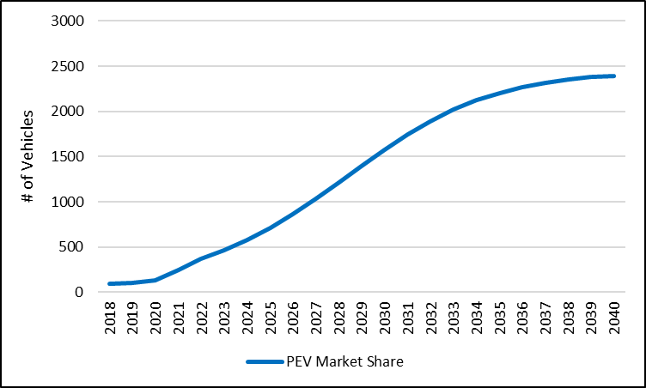
The PEV stock is multiplied by NREL’s hourly charging profile to calculate the total load requirement for residential charging.
Energy Efficiency and Electrification Costs
Generally, EE costs are estimated using reported $/kWh estimates for TDPUD programs in the past. The cost factor escalates over time with diminishing returns for each dollar spent on EE as savings become more costly in future years. The $/kWh cost also includes the present value of future savings from program dollars spent in each year. In the low load case, EE cost is assumed to be cheaper as new programs capture EE potential savings benefits and EE paired with electrification. Electrification spending is sourced from Truckee’s 2022 program results on an average $/kWh added basis. These costs could decline as technology improves for electric space heating and Truckee’s building electrification programs mature. Figure C-2 displays spending results for each of the load forecast scenarios as well as the additional Efficient Electrification scenario.
Figure C-2: Energy Efficiency and Electrification Spending by Load Forecast Scenario
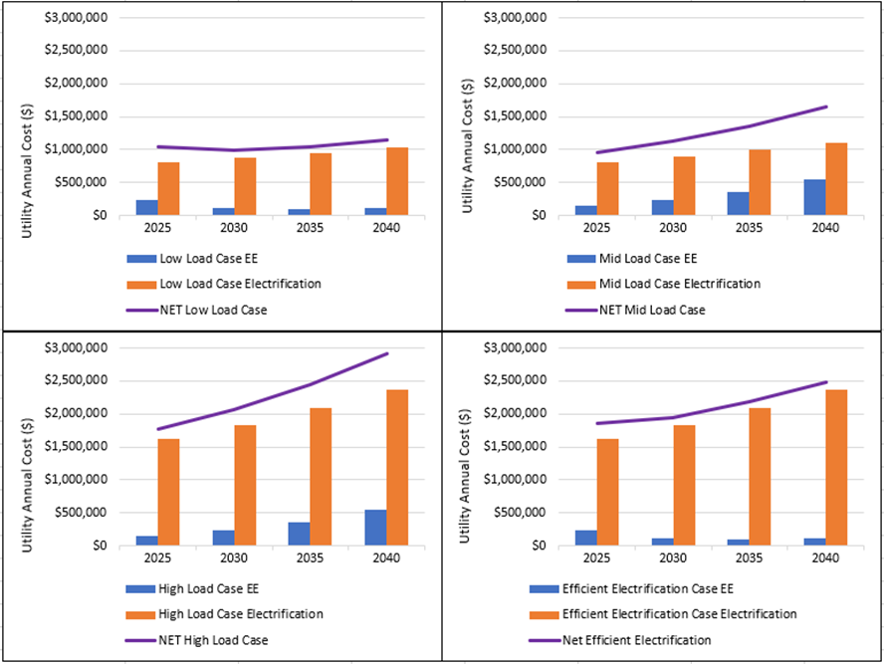

Appendix D: Exploratory Load Scenarios
This appendix contains three additional load scenarios, capturing the impacts of i) Heavy duty truck charging; ii) 100% residential PEV charging; and iii) Efficient Electrification. Table D-1 provides summary results for each exploratory scenario; the table repeats the Mid case load forecast for ease of comparison. Assumptions not specified are the same as in the Mid case.
Table D-1: Exploratory Load Forecast Scenario Descriptions
Additional Details of HD Truck Charging
Aspen looked at potential volume of trucks moving through the Truckee corridor however, the volume of truck traffic likely exceeds the capacity and space requirement needed to charge all of the trucks passing through. Charging one of these tractor-trailers takes 1-2 hours and uses approximately 1 MW each hour. This scenario assumes 4-6 MW worth of chargers operating concurrently which accommodates 100 to 150 trucks per day. Locating space for these trucks to stop and charge and the overall infrastructure cost for Truckee requires further study. Other concerns include decreased efficiency of batteries in cold weather and the accelerated deterioration of highway roads due to the increased average truck weight due to the heavy batteries on board.

Appendix E: Acronym List
AMI | Advanced Metering Infrastructure
BAA | Balancing Authority Area
BTM | Behind-the-Meter
CAISO | California ISO
CEC | California Energy Commission
CFPP | Carbon Free Power Project
CMUA | California Municipal Utilities Association
CVP | Central Valley Project
EE | Energy Efficiency
FY | Fiscal Year
GHG | Greenhouse Gas
IRP | Integrated Resource Plan
LSE | Load Serving Entity
LV | Low-Voltage
NNP | No New PPA
NPV | Net Present Value
NTUA | Navajo Tribal Utility Authority
NVE | NV Energy
OATT | Open Access Transmission Tariff
PEV | Plug-in Electric Vehicle
POU | Publicly Owned Utility
PPA | Power Purchase Agreement
PRM | Planning Reserve Margin
RA | Resource Adequacy
REC | Renewable Energy Credit
RPS | Renewable Portfolio Standard
SB | Senate Bill
SC | Scheduling Coordinator
SMR | Small Modular Reactor
SPPC | Sierra Pacific Power Company
TAC | Transmission Access Charge
TDPUD | Truckee Donner Public Utility District
TCID | Truckee-Carson Irrigation District
UAMPS | Utah Association of Municipal Power Systems
WAC | Wheeling Access Charge
WAPA | Western Area Power Administration

The UAMPS data is “gross,” meaning that it is before accounting for transmission losses.
A time series is a series of data points organized in time order, earliest to latest.
Aspen used a forecasting tool that applies decision-tree logic to increase predictive ability, correcting the errors of the previous trees iteratively to yield a more accurate prediction. Aspen’s implementation includes per capita income, month, hour, day of year, year, holidays, day of week, and quarter as predictive variables to yield hourly load.
The nomenclature follows the CEC’s demand forecast where they create a “baseline” forecast before adding additional load modifiers and a “managed” forecast including the load modifiers for their Low, Mid, and High demand cases.
Monthly load shapes are derived from TDPUD’s hourly AMI data for public charging load and solar generation or received kWh. Generated a monthly profile based off weighted meter data.
This forecast is an input into the IRP model, which assesses the resources needed to meet the load requirement.
The Twon of Truckee takes permit applications for solar PV installations. There have been limited applications to date, and the Town of Truckee has updated guidelines for exemptions. See: https://www.townoftruckee.com/government/community-development/building-and-safety/residential/project-scope/solar
For the forecast we consider Plug-in Electric Vehicles or PEVs as the DMV data and ICF Tahoe-Truckee PEV Readiness Plan both include plug-in hybrids and battery electric vehicles in their stock and trip data.
This uses a Bass Diffusion Curve and fit using expected market share from ICF’s Tahoe-Truckee PEV Readiness Plan. ICF’s report included market share for mid, low and high case.
DMV data is provided by zip code, and Aspen aggregated the relevant zip codes for Truckee to come up with historical PEV stock.
See page 20 for trip projections: https://www.energy.ca.gov/sites/default/files/2021-05/CEC-600-2021-030.pdf
The ICF Tahoe-Truckee PEV Readiness report cites the consumer preference for SUVs in Tahoe in order to navigate snowy roads. See page 35: https://www.energy.ca.gov/sites/default/files/2021-05/CEC-600-2021-030.pdf
While new EVs with AWD and 4WD will become available, there are still some limitations and downsides to battery efficiency at low temperatures that could limit use. See: https://pubs.acs.org/doi/epdf/10.1021/es505621s
Aspen looked at potential volume of trucks moving through the Truckee corridor however, the volume of truck traffic likely exceeds the capacity and space requirement to charge these trucks. Charging one of these tractor-trailers takes 1-2 hours and uses approximately 1 MW each hour. This scenario assumes 4-6 MW worth of chargers operating at the same time. This would accommodate 50 to 100 trucks per day. See article on Charging Specs: https://www.ptolemus.com/insight/is-tesla-semi-a-game-changer-part-1-tesla-semi-versus-other-electric-trucks/
PG&E states that compared to a mixed fuel home with two ICE vehicles, an all-electric home with two EVs doubles electricity consumption for the home. See: https://www.energy.ca.gov/data-reports/reports/integrated-energy-policy-report/2023-integrated-energy-policy-report/2023-0
This case assumes a market share of 18,000 EVs in Truckee and utilizes the same NREL load profile for charging.
The CEC uses the IOU and POU reported program savings in order to produce the statewide demand forecast for California. See CMUA’s annual reports here: https://www.cmua.org/sb1037-reports
How the study reached a nearly opposite conclusion for the District versus other utilities covered in it is unclear.
The CEC Building Decarbonization Assessment reports moving from aggressive electrification to efficient electrification will cost 5% more in total net cost, but decreases incremental grid demand by 17% or 8,000 GWh.
Further detail on spending estimates and EE and electrification cost assumptions are included in the appendix.
See Appendix A for the District’s compliance with the State RPS goals.
Round-trip efficiency is the percentage of electricity put into storage that is later retrieved. The higher the round-trip efficiency, the less energy is lost in the storage process.
https://www.nuscalepower.com/en/news/press-releases/2023/uamps-and-nuscale-power-agree-to-terminate-the-carbon-free-power-project
Assumed to be 15% for this IRP.
California Public Utilities Code Section 9620 requires local publicly owned utilities to meet a minimum planning reserve margin set by the Western Electricity Coordinating Council..
RECs are units that represent the clean energy created by specific renewable sources, such as solar energy resources and wind energy resources. One REC represents one megawatt-hour (MWh) of energy produced a by a renewable energy source.
Recognizing the constraints on the ability to obtain REC revenues, when the District is net long, we assumed a monthly $100,000 net REC sale revenue cap.
City of Palo Alto, 2018 Electric Integrated Resource Plan, PacifiCorp 2023 Integrated Resource Plan Volume I, March 31, 2023. Also, see “Training on Integrated Resource Planning for South Carolina Office of Regulatory Staff,” located at https://eta-publications.lbl.gov/sites/default/files/conducting_a_technical_review_of_an_irp.pdf
Battery storage typically charges during the early and late morning hours and discharges during the late evening hours when the net load (load net of solar generation) is the highest during the day.
The performance for the remaining three portfolios are provided in Appendix B.
See https://www.universityofcalifornia.edu/news/renewable-clean-hydrogen-power-coming-california-heres-what-you-need-know
The tornado diagrams for the remaining three portfolios are provided in Appendix B.
The Tahoe-Truckee Readiness Plan provides market share estimates for a low, medium and high case which translates to the District low, medium and high load forecast scenarios.
The current and historical plug-in electric vehicle data is sourced via DMV data for the relevant Truckee zip codes. This gives a count and trend line basis for estimating vehicle ownership by fuel type in the forecast period. CA DMV Vehicles by fuel type and zip code: https://data.ca.gov/dataset/vehicle-fuel-type-count-by-zip-code
The LDV EV load profile is estimated using the EVI-Pro Lite tool which provides charging profiles for residential LDV PEVs for 1000 cars on a 15-minute basis. The load profile was aggregated to hourly kWh/vehicle. The EVI-Pro Lite tool was developed under a collaborative effort by NREL, CEC, DOE funding and LBNL: https://afdc.energy.gov/evi-pro-lite
Aspen sourced truck traffic data from Cal Trans which gives the Annual Average Daily Truck Traffic by highway. See : https://dot.ca.gov/programs/traffic-operations/census.
This is assuming the largest truck under development with the largest charging capability in order to serve all trucks through the Truckee corridor. See article for example charging specs: https://www.ptolemus.com/insight/is-tesla-semi-a-game-changer-part-1-tesla-semi-versus-other-electric-trucks/
The California Transportation Commission released a study detailing potential truck charging costs for station developments, road maintenance and statewide estimates for zero-emissions freight stations needed. See: https://catc.ca.gov/-/media/ctc-media/documents/ctc-workshops/2023/063023-draft-sb671-assessment-technical-memorandum-a11y.pdf

